**E-Commerce KPIs**

1. Total Number of Customers
2. Total Number of Orders
3. Total Revenue
4. Average Order Value
5. Total Number of Products

1. Total Products Sold
2. Most Expensive Product
3. Least Expensive Product
4. Number of Orders Per Customer
5. Total Stock Quantity
6. Products Out of Stock
7. Total Orders in ‘2024-04-12’
8. Most Recent Order
9. Number of Orders by Month
10. Find all products that cost less than $50
11. Best Selling Product (by quantity)
12. Find all products that are out of stock:
13. Number of Orders by Day of Week
14. Average Order Value by Custome
15. 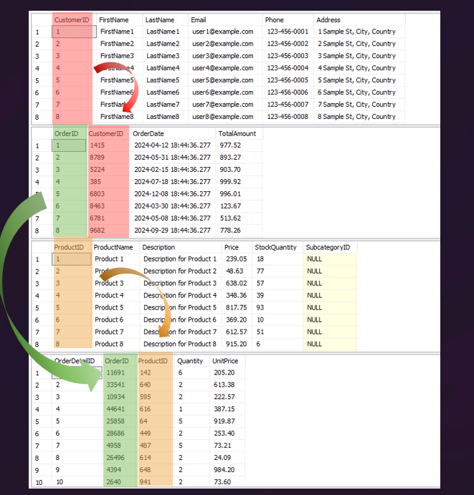Products with Price Above Averag